**REACT COURSE**

T Sree Sowmya

221910304044

Gitam Hyd CSE

**DAY-3 5/12/2022**

**Declaration of Variables:**

1)Var:

2)let:

whenever any variable is declared by using let ,variable should be used within that particular block.

3)const:

Whenever we declare any variable with const ,the value of variable will remain same,It will be throwing error we try to change to value of variable.

To execute “Gitam in function and class component

**Class**: 🡪

import React{Component},from ‘react’;

Class User extends Component

{ render()

{ return(

<h1>GITAM<h1/>

}

}

}

**Function:**

Function User(){

return(

<h1>GITAM<h1>

)

}

export default User;

**CLASS COMPONENT:**

**2) Declare a class component “university” and functionality of particular class component is to print your name and pin num..**

Export 🡪class component to app.js and run the application.

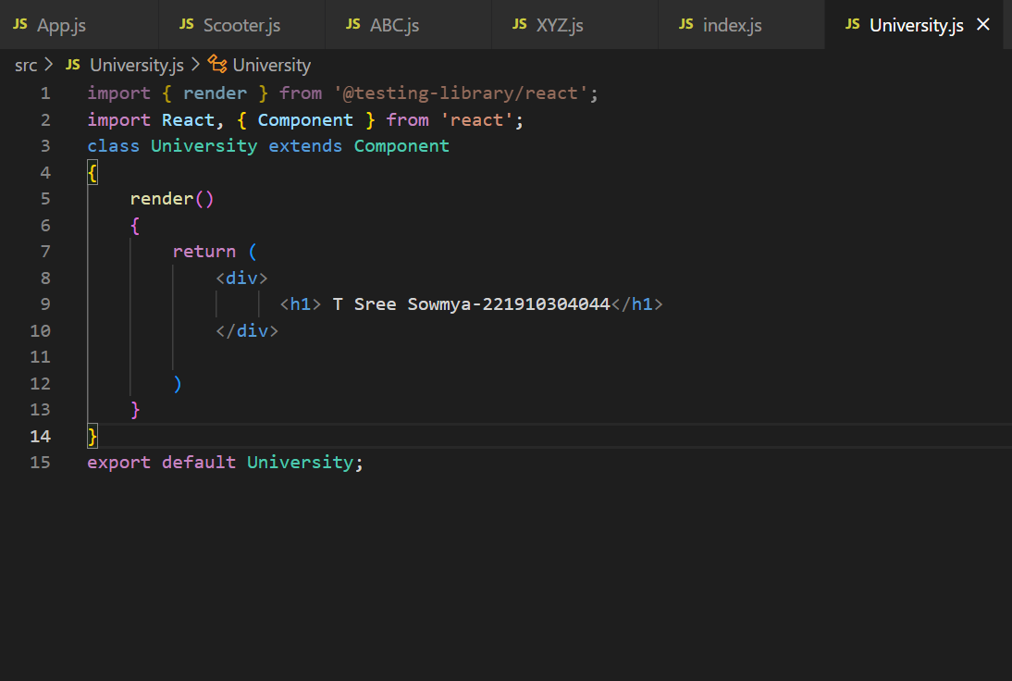

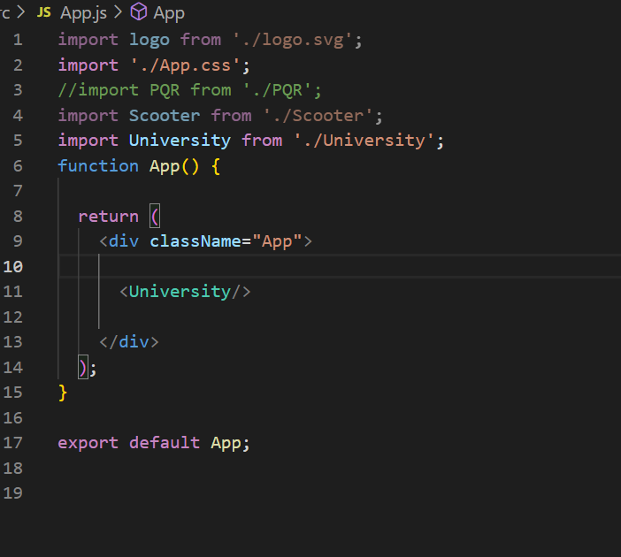

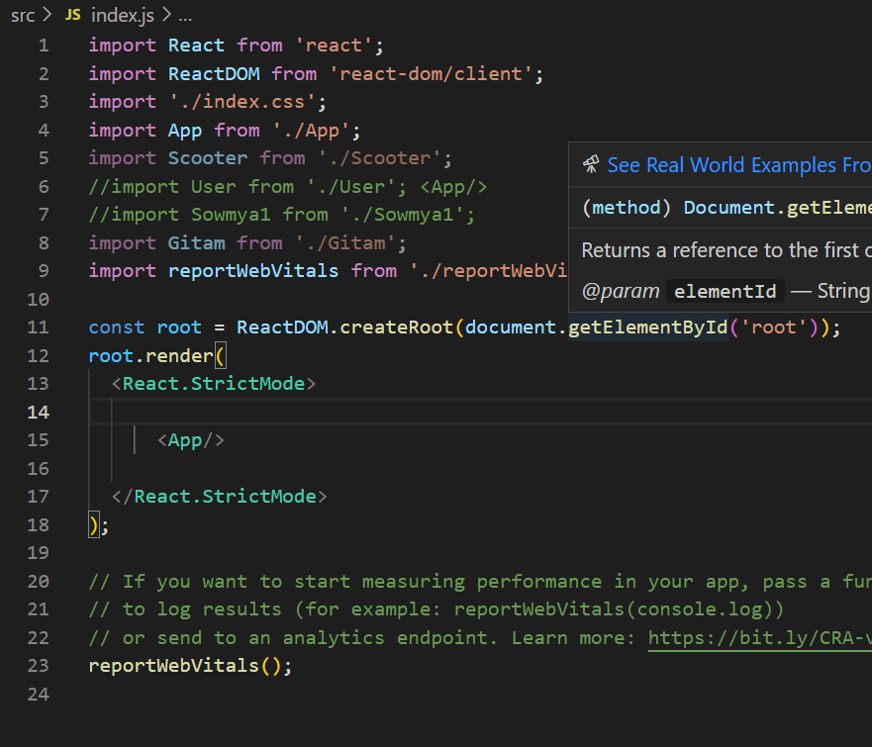

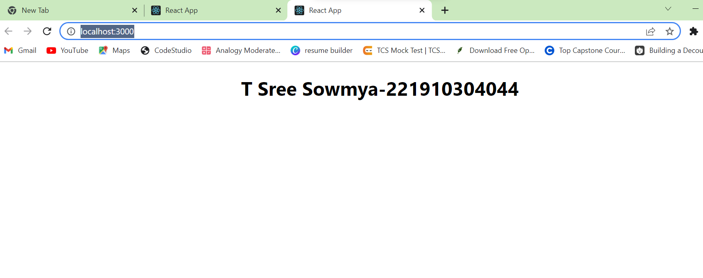

**ON CLICK AND BUTTON**

A button can be created by using button tag

Function Apps

{

Alert(“welcome”)

<Button onclick = {Apps}>Submit</Button>

Whenever submit button is clicked then🡪 by clicking on it 🡪directs to Apps🡪 Apps function prints Welcome

**Class work:**

**1) Use of Button(On click event)**

__________________________________

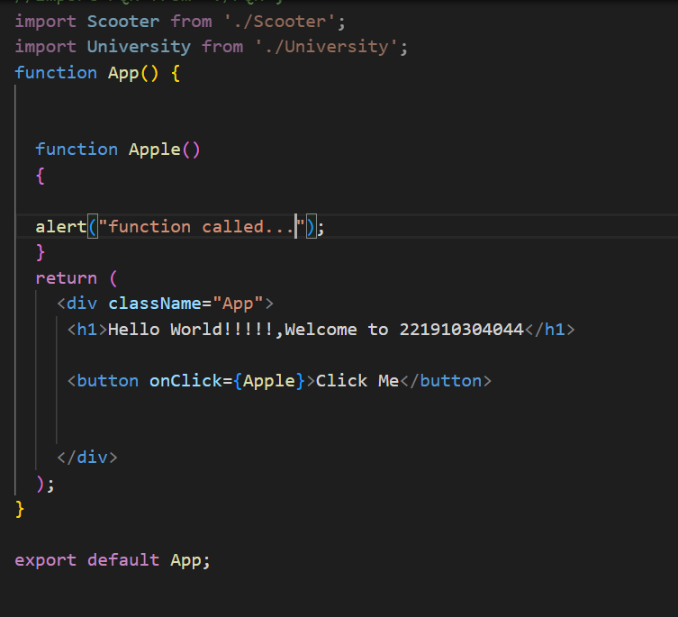

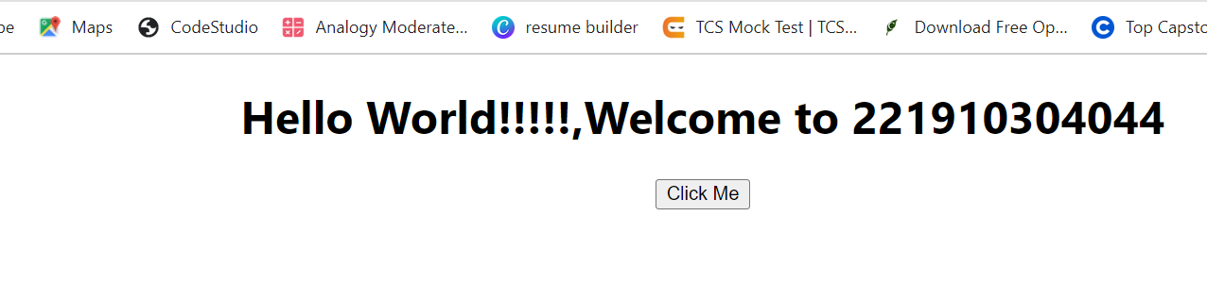

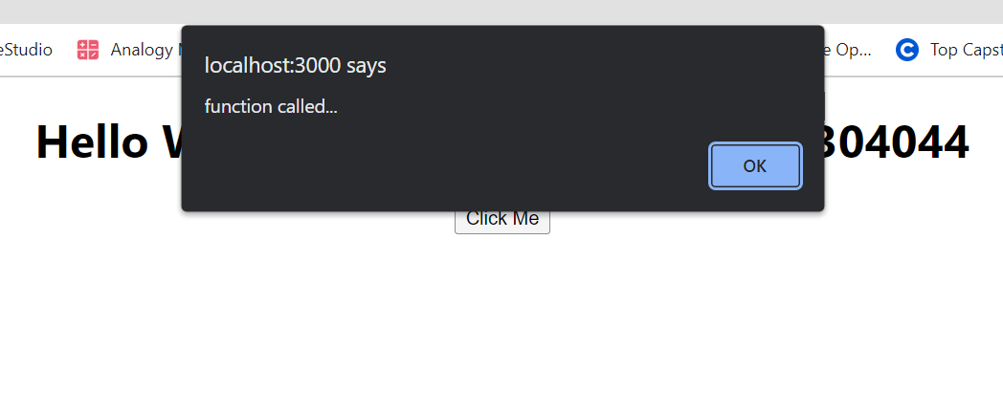

**2) Use of Arrow function()**

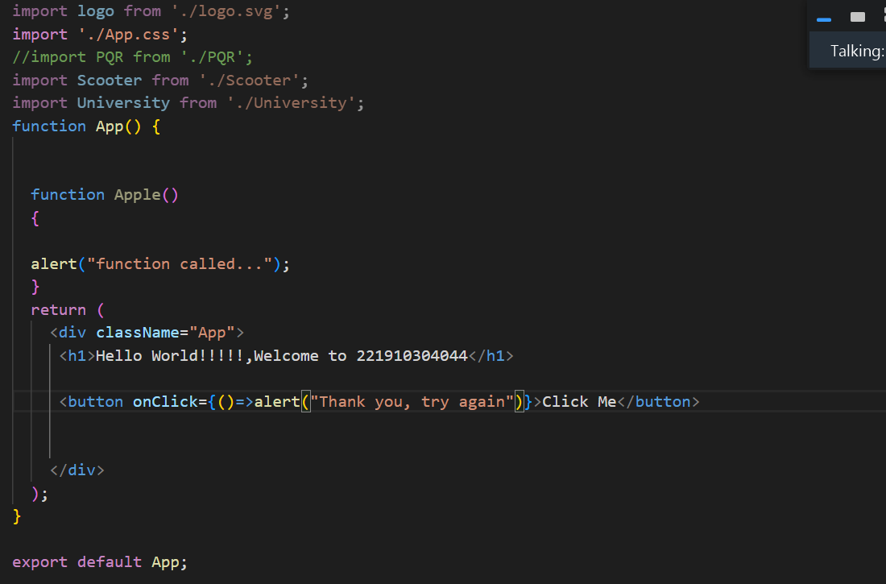

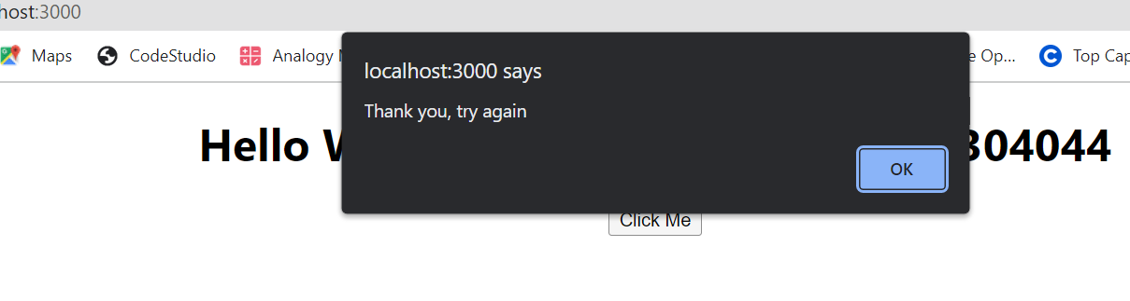

**USAGE OF VARIABLE:**

**1)**

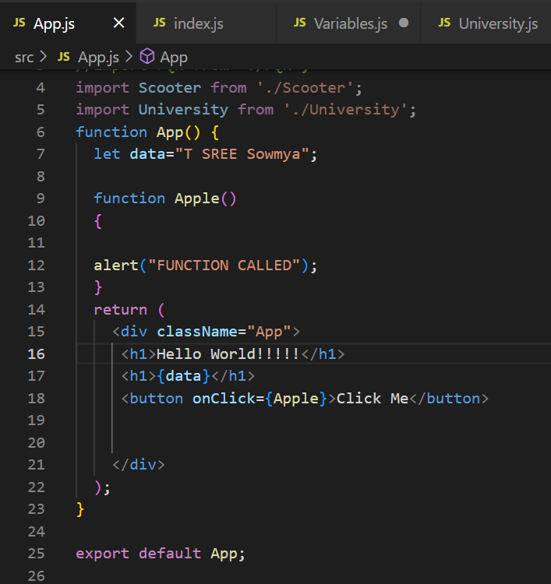

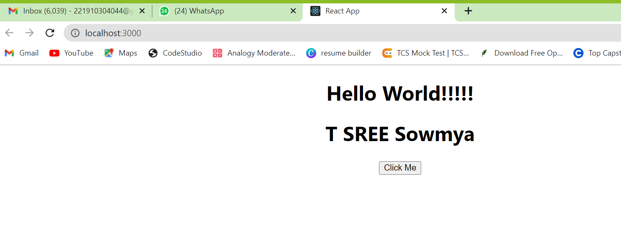

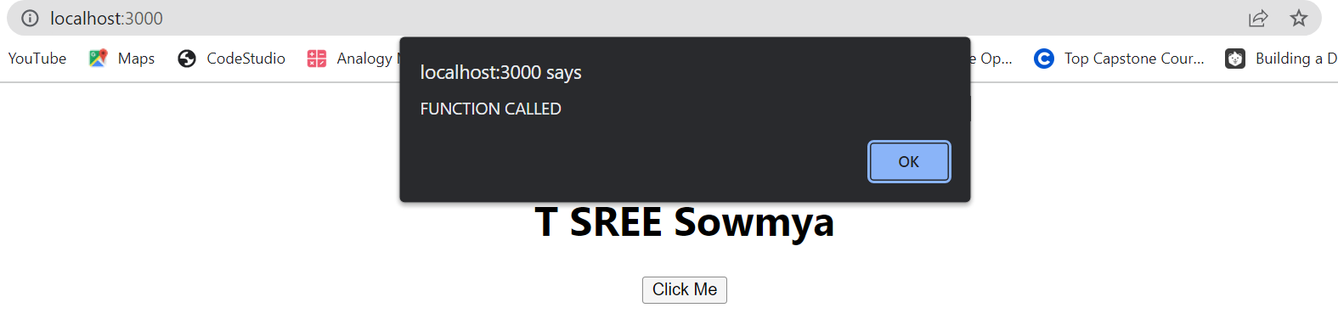

2)

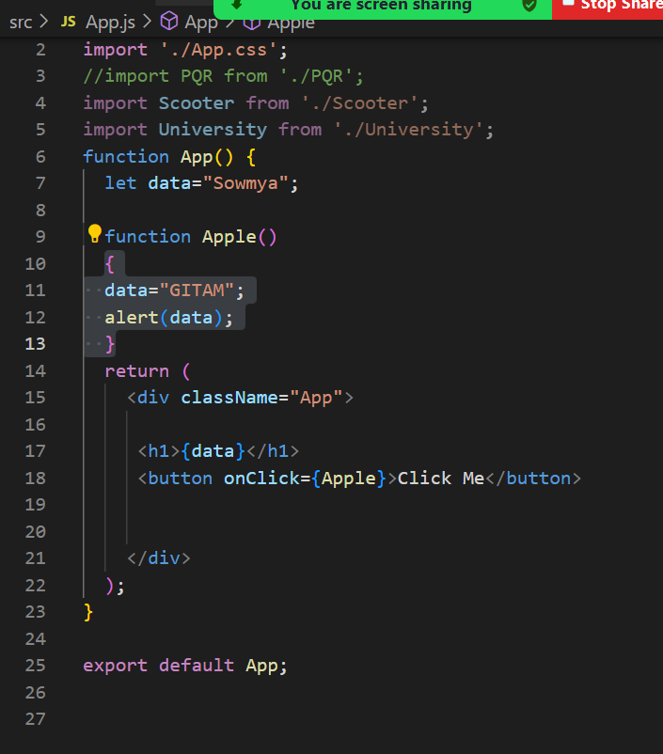

OUTPUT:

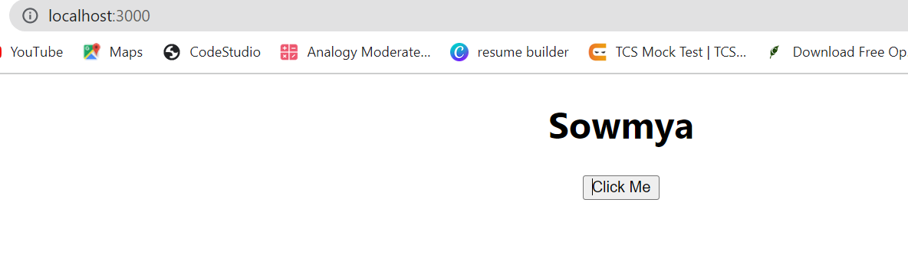

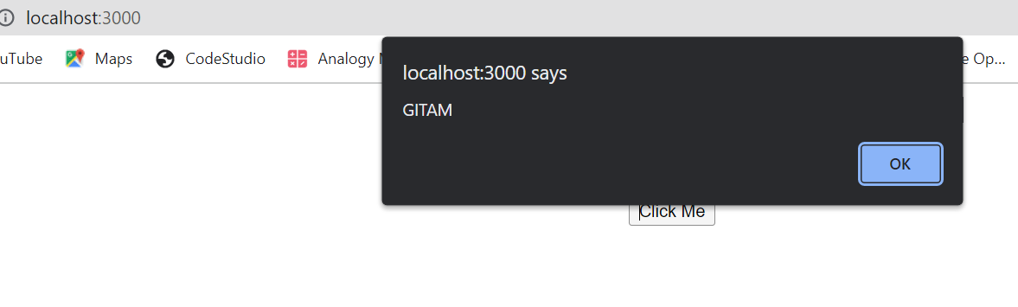

**ASSIGNMENT-1**

1. Create a class component called "GITAM" ,that class Component needs to print "WELCOME TO GITAM". Export that class component to App.js and execute the program

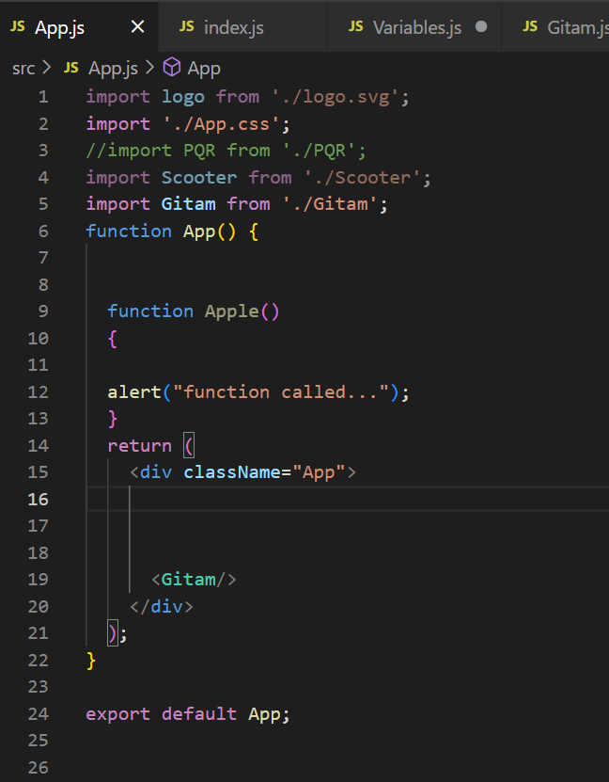

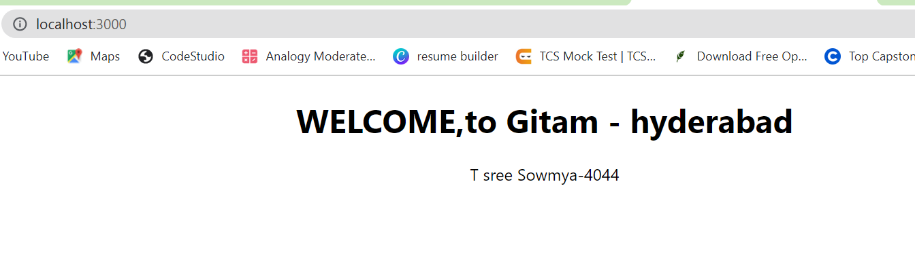

**2.In App.js , inside the App function, create one function called Banana and it need to return your name.**

**Create a button called GITAM, whenever GITAM is clicked, the function should be called.**

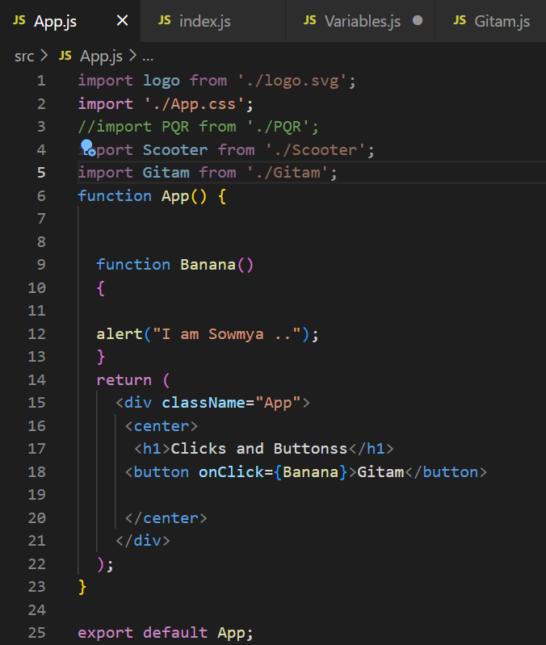

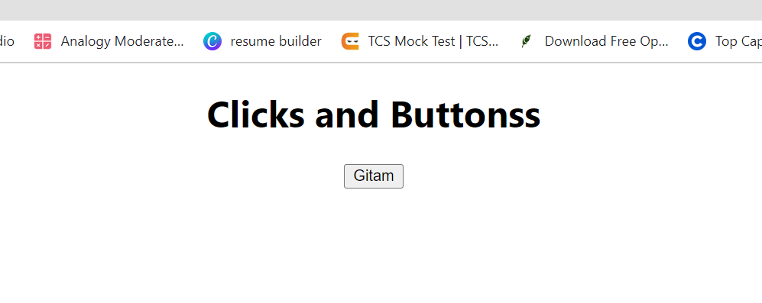

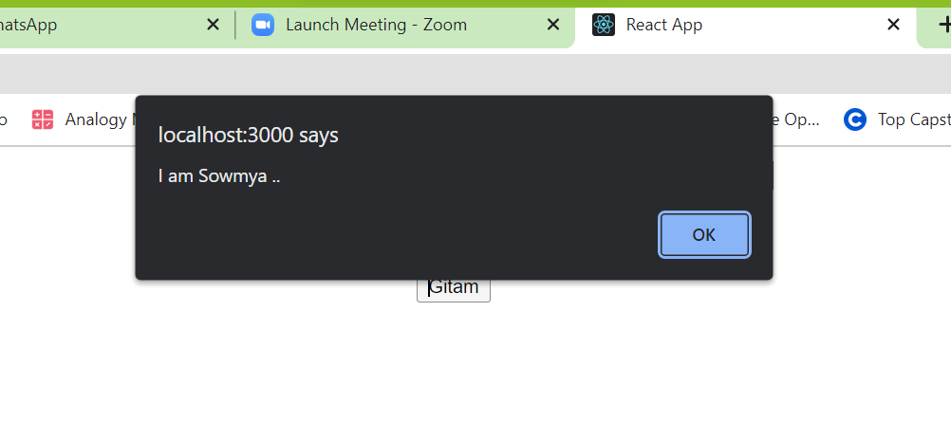

1. **In App.js, create a variable item, pass the value UNIVERSITY to that variable and print the value of that variable to the output screen two times by using the variable.**

